Nolan Bushnell

Nolan was born on February 5, 1943 in Clearfield Utah. Nolan started college at Utah State in 1961. In 1964 he transferred to University of Utah College of Engineering. While he was going to college he worked at Lagoon after 2 seasons he became manager of the games department. He loved being around all the arcades which would spark ideas for the future.

In 1969 him and an aqutents named Ted Dabney started a company named Syzygy. Then they made an arcade game named Computer Space. Sales of Computer space was over $3 million but was considered a failure.

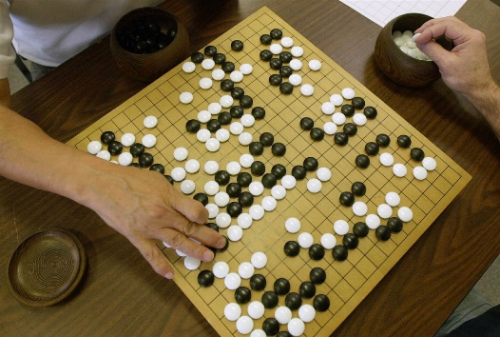 In 1972 Bushnell and Dabney set out on a new adventure. They learned that the name Syzygy was already taken by a few companies. So they decided on the name Atari instead. They named it Atari after a move in the board game “Go”